

Department of Electrical Engineering

Sukkur Institute of Business Administration University

**Analysis of ECG Signal and Heart rate using Arduino and AD8232 ECG Sensor, pulse sensor and Oximeter.**

Instructor: Dr. Ghulam Abbas

# GROUP MEMBERS:

MUHAMMAD QASIM

ABID UR RASOOL

**Pulse Rate (BPM) and ECG waveform monitor using Arduino & Pulse Sensor**

### **Overview of the project**

In this project, we will design Heartbeat/Pulse/BPM Rate Monitor and ECG signals using Arduino & Pulse Sensor. Below is the picture of the pulse sensor attach with the middle finger.

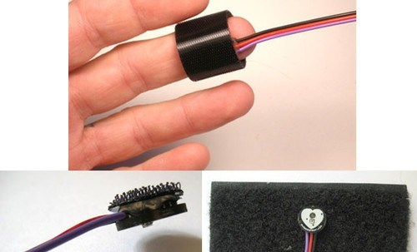This sensing element is kind of simple to use and operate. Simply Place your finger on prime of the sensing element and it'll sense the heartbeat by measurement the amendment in light-weight from the growth of capillary blood vessels.

**Pulse Sensor:**

#### **Introduction:**

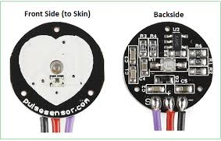

The **Pulse Sensor measure heart-rate.** It can be used by students, artists, athletes, makers, and game & mobile developers who want to easily incorporate live heart-rate data into their projects and it is easy to use. It contain an integrated optical amplifying circuit and noise eliminating circuit sensor. Clip the **Pulse Sensor** to your earlobe or fingertip then connect it your Arduino.

#### **Construction of Sensor**

The front of the sensor comes with the heart logo. This is where you place your finger. On the front side, you will see a small round hole, from where the green LED shines. Just below the LED is a small ambient light photosensor **APDS9008** which adjust the brightness in different light conditions.

On the back of the module you will find MCP6001 Op-Amp IC, a few resistors, and capacitors. This makes up the R/C filter network. There is also a reverse protection diode to prevent damage if you connect the power leads reverse.

#### **Pulse Sensor pin out:**

The pulse sensor has three pins: VCC, GND & Analog Pin.

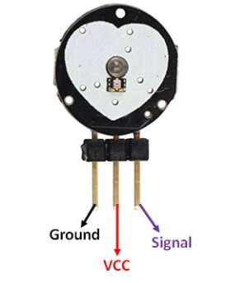

The module operates from a 3.3 to 5V DC Voltage supply with an operating current up to 4mA.

### **Connection of Arduino & Pulse Sensor**

Below is the connection of Pulse sensor with the arduino

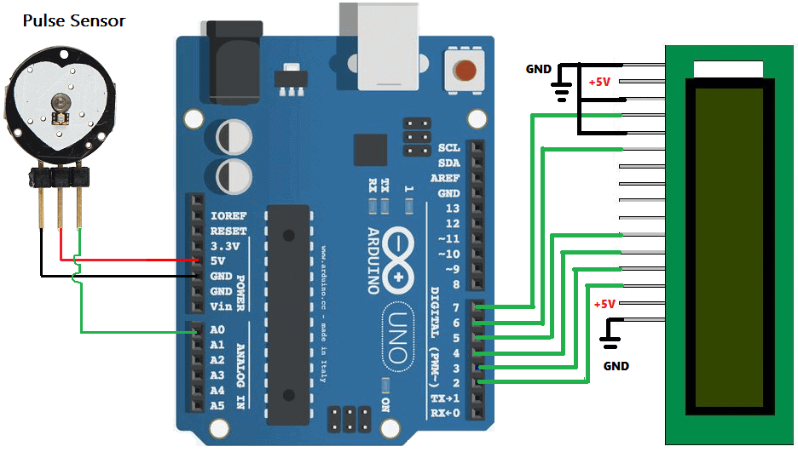

Connect the VCC pin of the Sensor to Arduino 5V Pin & GND to GND. Connect the Analog output pin of the sensor to the A0 pin of the Arduino.

### **Working of the Project:**

### When a heartbeat happens, blood is pumped-up through the physique and gets squeezed into the capillary tissues. Consequently, the amount of those capillary tissues will increase. However in between the 2 consecutive heartbeats, this volume within capillary tissues decreases. This alteration in volume between the heartbeats affects the quantity of sunshine which will transmit through these tissues. This may be measured with the assistance of a microcontroller. The pulse sensing element module contains a light-weight that helps in measurement the heart beat rate. Once we place the finger on the heart beat sensing element, the sunshine mirrored can amendment supported the amount of blood within the capillary blood vessels. This variation in light-weight transmission and reflection are often obtained as a pulse from the output of the heart beat sensing element. This pulse are often then conditioned to live heartbeat so programmed consequently to scan as heartbeat count victimization Arduino.

### **Source Code:**

The source code is also simple.

First, you would like to feature the heart beat sensing element library file. The PulseSensor library contains a range of example sketches. You’ll be able to attempt PulseSensor obtaining Started example.

|  |
| --- |
| CODE |
| // Variables  int PulseSensorPurplePin = 0; // pulse sensing element PURPLE WIRE connected to ANALOG PIN 0  int LED13 = 13; // The on-board Arduino LED  int Signal; // holds the incoming raw data. Signal value can range from 0-1024  int Threshold = 550; // Determine which Signal to "count as a beat", and which to ingore.  // The SetUp Function:  void setup() {  pinMode(LED13,OUTPUT); // pin that will blink to your heartbeat!  Serial.begin(9600); // Set's up Serial Communication at certain speed.  }  // The Main Loop Function  void loop() {  Signal = analogRead(PulseSensorPurplePin); // Read the PulseSensor's value.  // Assign this value to the "Signal" variable.  Serial.println(Signal); // Send the Signal value to Serial Plotter.  if(Signal > Threshold){ // If the signal is above "550", then "turn-on" Arduino's on-Board LED.  digitalWrite(LED13,HIGH);  } else {  digitalWrite(LED13,LOW); else should be below "550", thus "turn-off" this LED. }  delay(10);  } |

After uploading the code, open the Serial Monitor, you'll see the guts/hearts Beat Rate. To examine the encephalogram Graph, open the Serial Plotter from the Tools Menu.

**Pictures**

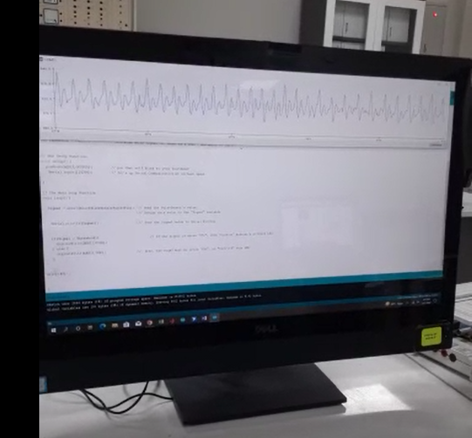

# Interfacing MAX30100 Pulse Oximeter Sensor with Arduino

**Overview**

In this project we will I**nterface Pulse Oximeter Sensor with Arduino**. The **Oximeter Sensor** is capable of measuring **Blood Oxygen** & **Heart Rate**. The blood Oxygen Concentration termed **SpO2** is measured in Percentage and **Heart Beat is measured in BPM.**

The MAX30100 combines two **LEDs**, a **photodetector**, **optimized optics**, and low-noise analog signal processing to detect pulse oximetry and heart-rate signals

### **How does Pulse Oximeter Works?**

**Oxygen** enters through the lungs and then it is passed on into whole blood. The blood carries oxygen to different organs in our body. The main way through which oxygen is carried in our blood is by **hemoglobin**. During a pulse oximeter reading, a small clamp-like device is placed on a finger, earlobe, toe because thers are the sensitive organs. .

### working of Pulse Oximeter

Small rays of light pass through the blood in the finger and the amount of oxygen is being measured. It is done this by measuring changes in **light absorption** in **oxygenated** or **deoxygenated blood**.

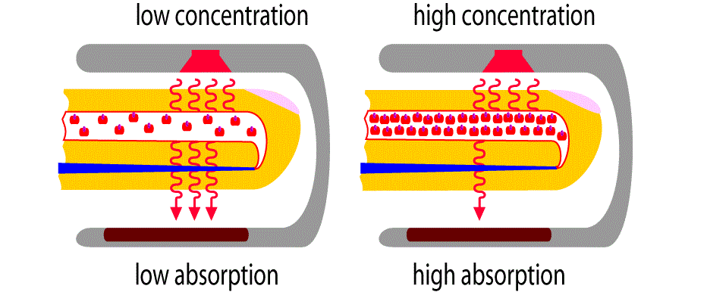

### **MAX30100 Pulse Oximeter**

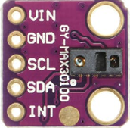

#### **Features**

1. Consumes very low power
2. operates from 1.8V and 3.3V
3. Ultra-Low Shutdown Current (0.7µA, typ).
4. Fast Data Output Capability
5. I2C Interface

### **Connecting Pulse Oximeter Sensor with Arduino**

The circuit diagram and connection is very simple. Connect the pins according to the figure given below

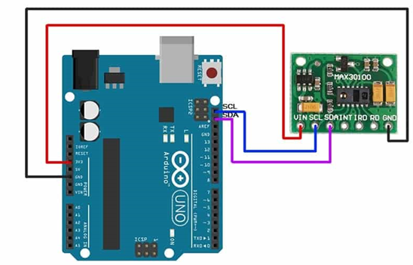

Connect the Vin pin of Oximeter sensor to Arduino **5V** or **3.3V** pin, GND to GND. **SCL pin to A5 and SDA pin to** **A4 pin** of Arduino.

**Source Code**

You need to download Sparkfun’s MAX30102 library or you can use the Arduino IDE’s library manager (Sketch > Include Library > Manage

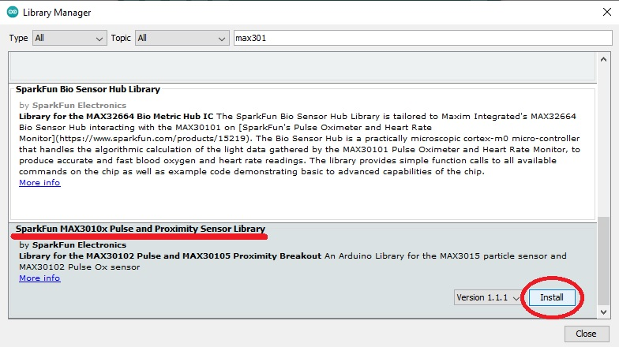

You can use any example for your project

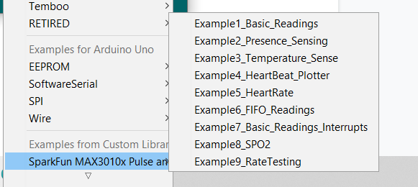

|  |
| --- |
| Code |
| #include <Wire.h>  #include "MAX30100_PulseOximeter.h"    #define REPORTING_PERIOD_MS     1000    PulseOximeter pox;  uint32_t tsLastReport = 0;    void onBeatDetected()  {      Serial.println("Beat!");  }    void setup()  {      Serial.begin(115200);      Serial.print("Initializing pulse oximeter..");        // Initialize the PulseOximeter instance      if (!pox.begin()) {          Serial.println("FAILED");          for(;;);      } else {          Serial.println("SUCCESS");      }       pox.setIRLedCurrent(MAX30100_LED_CURR_7_6MA);            pox.setOnBeatDetectedCallback(onBeatDetected);  }    void loop()  {      //call update as fast as possible      pox.update();      if (millis() - tsLastReport > REPORTING_PERIOD_MS) {          Serial.print("Heart rate:");          Serial.print(pox.getHeartRate());          Serial.print("bpm / SpO2:");          Serial.print(pox.getSpO2());          Serial.println("%");            tsLastReport = millis();      }  } |

After the code is uploaded, open the serial monitor to see the values as shown in the image. Initially the the BPM & SpO2 value appears as incorrect value but soon you can observe the correct stable reading.

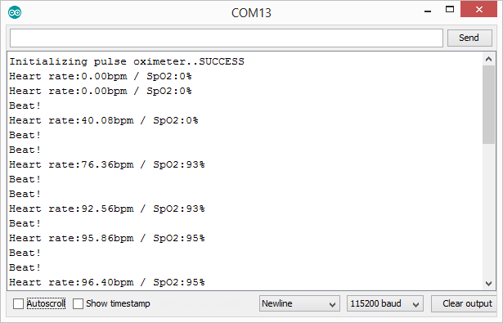

# ECG Graph observance with AD8232 graph sensing element & Arduino

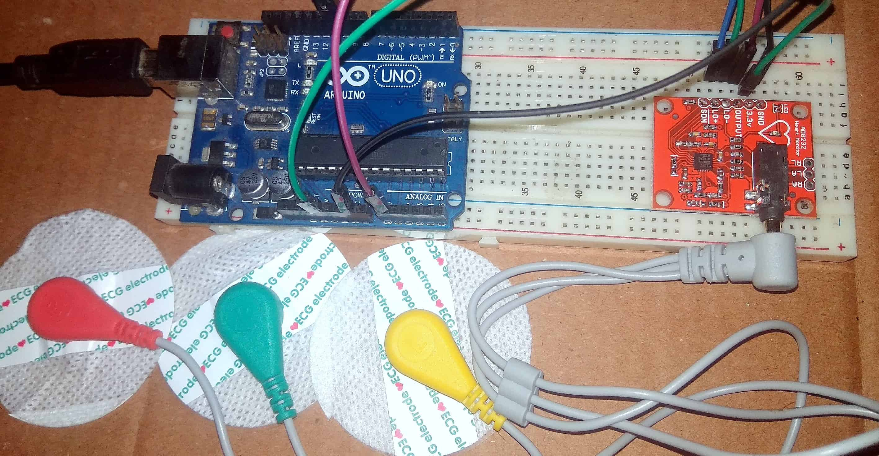

**Overview**

Heart diseases are getting a giant issue for the previous couple of decades and plenty of people die due to health issues Therefore, heart disease cannot be taken lightly. By analyzing or observance the graph signal at the initial stage this sickness are often prevented. Therefore we tend to gift this project, i.e graph observance with AD8232 graph sensing element & Arduino with graph.

**AD8232 Sensor**

The AD8232 may be a neat very little chip to live the electrical activity of the heart. This electrical activity are often charted as associate degree graph or graphical record.

The AD8232 ECG sensor is a commercial board used to calculate the electrical activity of the human heart. This action are often chart like associate degree graphical record and therefore the output of this is often associate degree analog reading. Electrocardiography is employed to assist diagnose varied heart conditions. Electrocardiograms are often terribly noisy, therefore to cut back the noise the AD8232 chip are often used. The regulation of the graph sensing element is like associate degree operational electronic equipment to assist in obtaining a transparent signal from the intervals merely.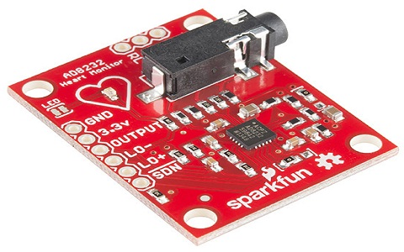

### **Applications of AD8232 ECG Sensor**

**The applications of the AD8232 graph sensing element embrace the subsequent.**

* Monitoring of heart and fitness activity
* Handy ECG
* Monitoring of remote health
* Used in gaming devices
* Acquisition of biopotential signal
* [Biometrics](https://www.elprocus.com/biometric-authentication-system-applications/)
* Physiology studies
* Prototyping of biomedical instruments
* Variability of heart rate
* Interaction of human-computer
* Psychophysiology

**What is ECG?**

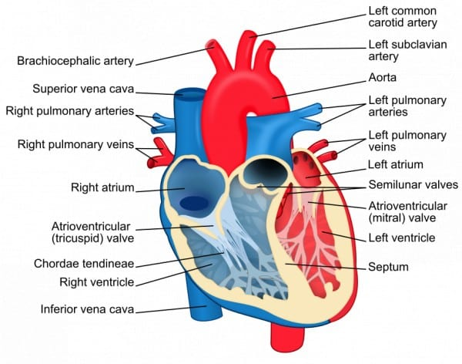

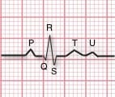An Electrocardiograph may be a paper or digital recording of the electrical signals within the heart. The graph is employed to work out pulse rate, regular recurrence, and alternative data relating to the heart’s condition. ECGs area unit is to facilitate diagnose heart arrhythmias, heart attacks, pacemaker operate, and failure.

ECG can be analyzed by studying components of the waveform. These waveform components indicate cardiac electrical activity.

1. **The P wave**: This represents a contraction of the atria. This is referred to as depolarization or the **squeezing effect**. This electrical wave represents blood being pumped out of the atria and into the ventricles.
2. **The QRS Complex**: This represents a **contraction of the ventricles**. This is the squeezing of the ventricles. This entire wave complex represents **blood being pumped out of the ventricles** and into the rest of the body.
3. **The T Wave**: This represents a relaxation of the ventricles. This is referred to as repolarization or filling of the ventricles. It represents blood filling the ventricles from the atria.
4. **The U Wave**: This wave really has no known reason for being there so we don’t have any normal interpretation. However, a prominent U-Wave could indicate a serious cardiac issue.

### **Medical uses of ECG**

An ECG record is often a helpful thanks to determine whether or not your high vital sign has caused any harm to your heart or blood vessels. Thanks to this, you'll be asked to possess associate degree graph once you area unit 1st diagnosed with high vital sign.

Some of the items associate degree graph reading will discover are:

1. Sterol hindering up your heart’s blood provide2. A heart attack in the past

3. Enlargement of one side of the heart

4. Abnormal heart rhythms

### **AD8232 ECG Sensor**

This sensor element may be a cost-efficient board which live the electrical activity of the heart. ECGs are often very clattering, the AD8232 Single Lead pulse rate Monitor acts as associate degree op-amp to assist acquire a transparent signal from the PR and QT Intervals simply.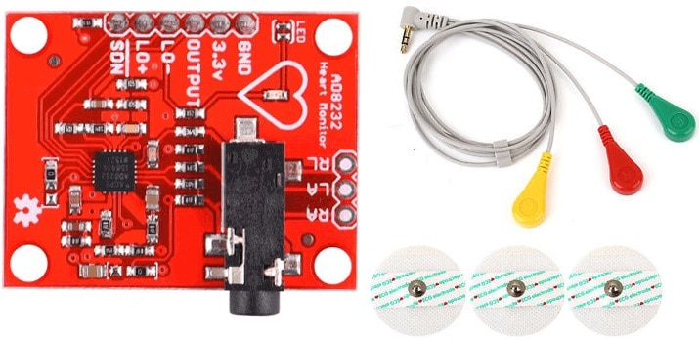

The AD8232 is associate degree integrated signal learning block for Electrocardiograph and alternative bio potential mensuration applications. It is designed to extract, amplify, and filter small bio potential signals in the presence of noisy conditions, such as those created by motion or remote electrode placement.

**Connection between Arduino AD8232 Sensors**

The AD8232 pulse rate Monitor breaks out 9 connections from the IC. we tend to historically decision these connections “pins” as a result of they are available from the pins on the IC, however they're truly holes that you simply will solder wires or header pins to. We’ll connect 5 of the 9 pins on the board to Arduino. 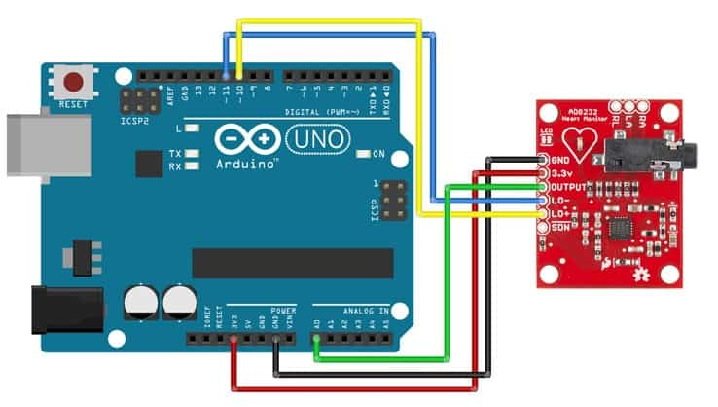

The five pins you need are labeled GND, 3.3v, OUTPUT, LO-, and LO+.

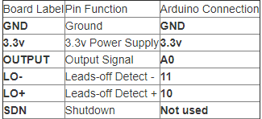

### **AD8232 ECG Sensor Placement on Body**

The closer to the heart the electrodes are, the better the measurement. The cables area unit color-coded to assist determine correct placement.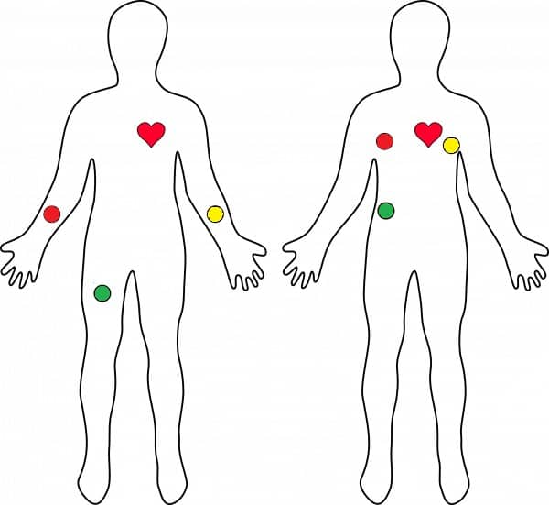

Red: RA (Right Arm)  
Yellow: LA (Left Arm)  
Green: RL (Right Leg)

### **Arduino Source Code**

|  |
| --- |
| Code |
| void setup() {  // initialize the serial communication:  Serial.begin(9600);  pinMode(10, INPUT); // Setup for leads off detection LO +  pinMode(11, INPUT); // Setup for leads off detection LO -    }    void loop() {    if((digitalRead(10) == 1)||(digitalRead(11) == 1)){  Serial.println('!');  }  else{  // send the value of analog input 0:  Serial.println(analogRead(A0));  }  // Wait for a touch to stay serial information from saturating  delay(1);  } |

Once the code is uploaded, see the values on serial monitor and graph on serial plotter

**Pictures**

ECG graph in the serial plotter of arduino.

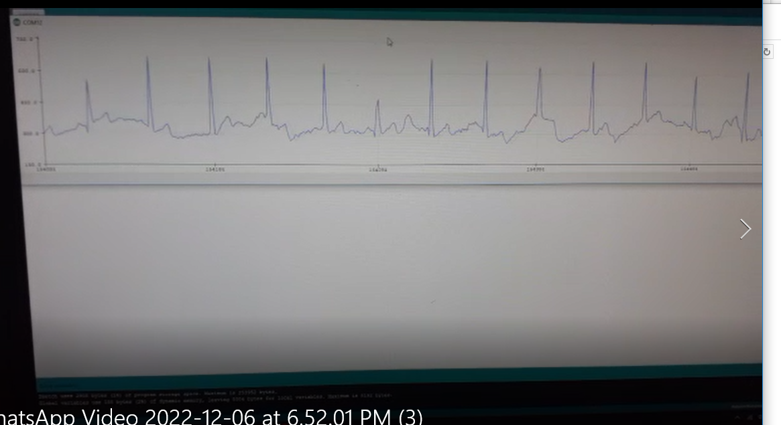

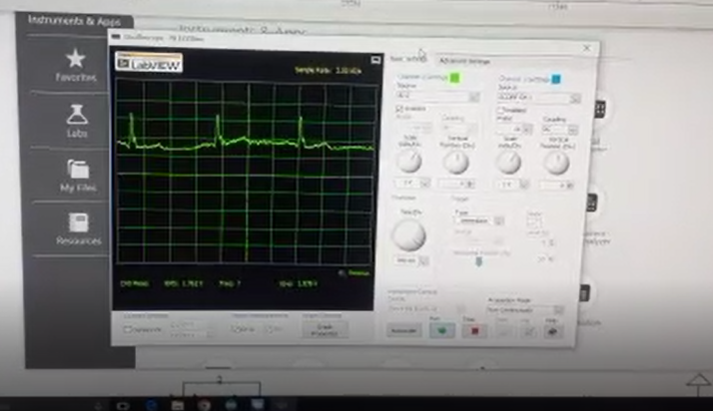ECG graph in NI Elvis Oscilloscope

ECG graph in Oscilloscope

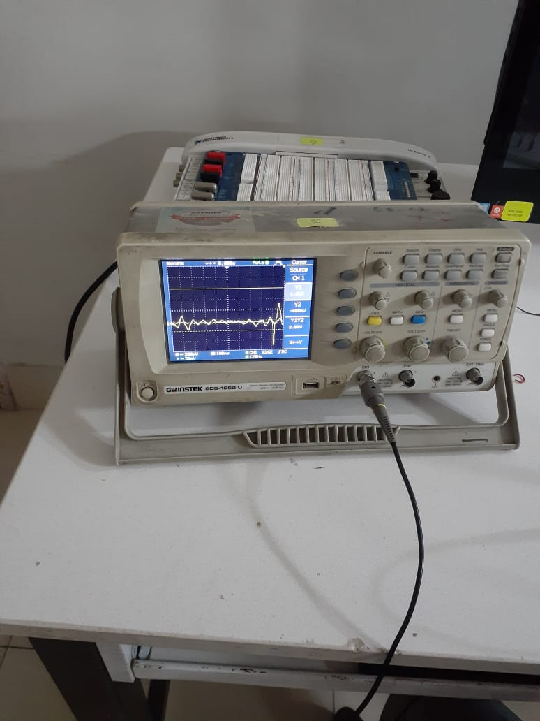

**Google Drive Videos Link**

Videos are uploaded on following link

<https://drive.google.com/drive/folders/13yRZ_nTpVv-RaMb1pIRyJG5HwTYgyLbV?usp=share_link>